Amusement Park Simulation Final Project Report

Compiled in Simio Academic Edition

Group 3

Prepared For: Professor Osman Aydas

Prepared By: Deepa Palariya, Vasudha Gulati, [Ivana Ljuljdjurovic](https://moodle.oakland.edu/user/view.php?id=229395&course=278126) and [Bruno Ceco](https://moodle.oakland.edu/user/view.php?id=285318&course=278126)

A detailed amusement park Simio model was developed, reviewed and analyzed. A comprehensive amusement park Simio model publication includes fast pass and “non-fast pass (Regular)” identification as two main entities, along with travel time schedule and wait times for the activities and rides available along the model. The entire publication represents a detailed analysis of the overall statistics gathered for all the activities including arcades and ride components.

In addition, for both fast pass and non-fast pass components, the wait times are considered with limiting the number of restroom visits to two which includes to and from walk times. As per the analysis, the case where the number of customers waiting is large, for instance, 100 customers, the customer will return to the main area which is the Central node in the Simio model and select another activity for completion.

The amusement park in general includes many activities to keep the customers busy throughout their visit which includes a roller coaster, a Ferris wheel, an arcade, carnival games (one area), concessions, and a bathroom area. Once a customer enters the park, they are being designated as either “fast pass” or “non-fast pass” customers. Upon arrival, the customers can spend their day enjoying themselves in the park participating in different activities given certain statistics and decision-criteria are met and maintained.

Once a customer enters the park, they are sent to the ticket counter which is the server in the Simio model and hence helps designate the customer as either “fast pass” or “non-fast pass” customer. This will help collect and analyze the model statistics such as wait times, decision criteria and other useful information required to build this model. The Simio model uses a categorization path that the customers use to travel based on whether they are either “fast pass” or “non-fast pass” customers. This information will further be used to include the wait time designations and will help in the decision making process, discussed in later publication.

Further, at the customer source, the customers can decide the first activity that they would like to enter into, at the park, based on the input provided which determines the statistics and conditions for such activities. For instance, as per the model, 50% of customers will prefer the arcade, while 50% of the customers don’t prefer the arcade hence will go for another activity such as rides, games etc. This selection of what a customer is choosing over the other will occur at the Central node in the Simio model.

The Central node will act as a middle point monitoring the wait times for both “fast pass” and “regular” customers separately, meaning, for how long both the customers were in the park. In addition, the criterion mentioned above - limiting the number of restroom visits to two will also be analyzed in the process variable within the Central node. A critical information to note here is the timing of the park which will also be noted within the Simio model. As per the park timings, the park will close at 10pm, meaning that all customers must leave the park before this time in order to ensure the park can close.

As mentioned in the details for building the Amusement park Simio model, the arrival rate schedule was provided which specified time intervals at which the customers will arrive, based on the arrival rate. The details included the time interval for customer basis arrival rate per hour. The below screen print shows the arrival rate schedule as per the model details and the Simio table set with the time scheduled as asked. The important thing to note here is the two time slots noted at the bottom component of the table (showing both zero) which implies that the park will still be open, but new customers would not be entering the park at this time. This is due to the fact that the time intervals stop at 6pm, but the park is open until 10pm every day.



The details for building the Amusement park Simio model also specifies how long a “fast pass” and “regular” customers wants to wait in order for them to be satisfied and not satisfied. For instance, the “fast pass” are dissatisfied if they have to wait for more than 10 minutes and the regular customers become extremely are dissatisfied if they have to wait for more than 60 minutes. The maximum wait time was indicated through the use of a real property definition in Simio, which highlights that “fast pass” and regular customers do not wish to wait longer than 10 and 60 minutes respectively while in the park.



The Amusement park description also provides specifics throughout the initial conditions to be implemented in the Simio model entailing limitations to the activities a customer is required to follow while enjoying in the park. For instance, 50% of customers will select to enjoy the arcade, while 50% of the customers will not select the arcade. In addition, customers are allowed to visit the restroom either one, or twice which is randomly assigned. Logics are assigned to satisfy such conditions. However, a critical note is that just because the customer can visit the restroom for a maximum of two times, it does not imply that they will complete this task. This logic assignment is completed at the beginning of the process at the customer source.



Initially in the description, a criterion was indicated noting the time in park distribution. Based on statistical probability, the criterion was set with the majority of customers spending approximately four hours in the park and the least spending only 30 minutes. A random discrete distribution set in the model entity was used to incorporate this in our Simio Model. Even though the time in park is listed in hours in the project description, changing it to minutes will help to run the experiment in minutes as required in the description.



In addition, a condition was added highlighting that each visitor to the park can only visit the concession area once. A logic property was added in our Simio file which will help monitor how many times the customer, regardless of fast pass or regular, visited the concession stand. One important thing here to be noted is that concession stand visits will not be included until the customer has physically entered the stand and completed their task. After they have entered the stand, they will be unable to enter the concession stand again for the duration of their visit.

The most complex processes occur at the central node since it defines where a customer will go based on various factors requiring validations. For instance, validation required for a customer to enjoy an activity includes whether the customer has visited the restroom, whether the customer has visited the concession previously in addition to the decision a customer is making which activity to do next. Also, the validation considers whether the customer will be interested in visiting the arcade or not which is an optional activity and operates like the other validation logics, if a customer does not wish to visit the arcade, he will enjoy another activity. To make sure these validations work, multiple steps are involved in the central node process to allow the model to record these details which will be presented in the appendix and the presentation of the model.

In the central node process, to record that the park closes at 10 om which is mentioned in the model at the start, earlier, a logic is applied at the central node along with a time lapse step included in the processing data that determines the park closing and time required for that. 

The below screenshots show the Customer walk in times in minutes. To include this in Simio, a time path was created for each activity and the logic was assigned to the respective time path. The time assigned to the respective activity was according to the description. For instance, if a customer visits an arcade, a random exponential mean of 2 minutes along with an offset of 3 minutes was assigned. Each time path and time assigned to it is different and based on the below specification as described in the model description manual. Similarly, the time path for Roller coaster will have a random exponent mean of 1 minute and an offset time of 1 minute. 

In addition, the distribution of time spent in other areas was also listed in the model description. For instance, in the area Bathroom, the processing time is a random triangular with intervals of 3,5,8 as listed indicating how much time a customer will stay in this area. Different intervals for other areas such as Carnival games, arcade and concessions are also noted. Also, the capacity which means the number of customers that can be in that area waiting for their turn is also defined along with the buffer capacity. For instance, for Arcade, 30 customers can enter the arcade as capacity defined and 5 customers can be waiting outside to enter the arcade which is the defined buffer capacity. 

For both Ferris wheel and Roller coaster, it is important to take into account each ride's capacity. The available vehicles on the ride, followed by the no of members riding in those vehicles are defined as capacities. The available car for roller coaster and ferris wheel is given as 2 and 30 respectively which is defined in the Parent input buffer logic for the Roller coaster and ferris wheel entrance.



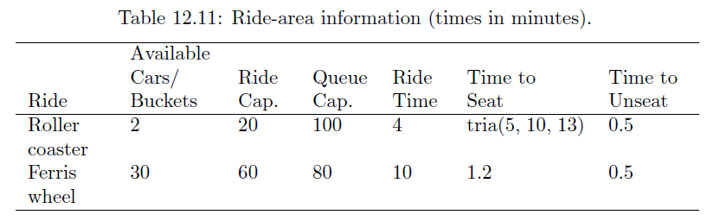

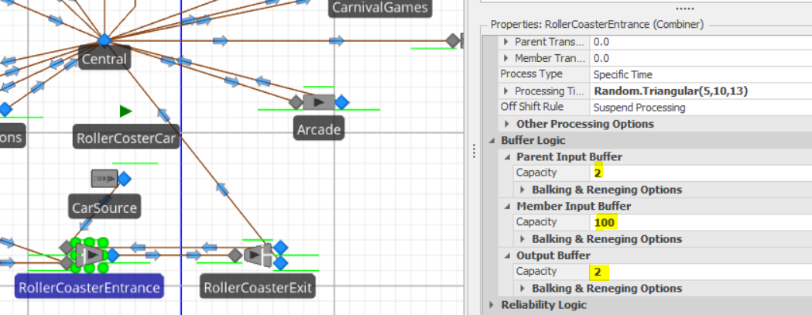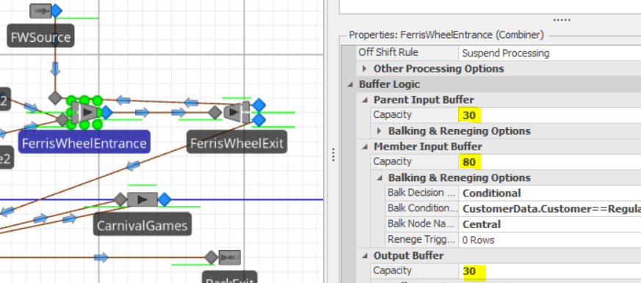

For instance, if there are 10 vehicles and 20 passengers, 2 passengers can also be seated in the conveyance vehicle for the entire duration of the trip which is indicated in our model by the "RCSource" and “FWSource”.

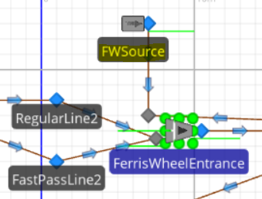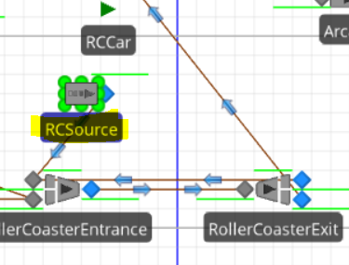

As per the processing times given for each roller coaster and ferris wheel entrance. The "start" time is the actual loading time to board the vehicle, followed by the ride's duration and an estimated 0.5 minute unloading time which is the time taken by the customer to leave the vehicle. This route has been set aside for both riding variants. We have defined the processing times as Random.Triangular(5,10,13) and 1.2 for RollerCoaster and FerrisWheel respectively.

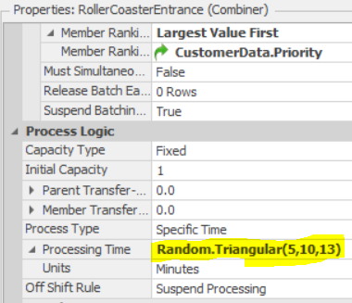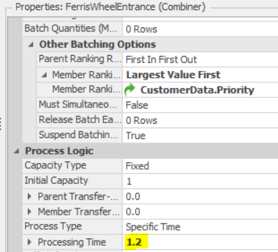

Finally, the entire simulation for the amusement park ran for 12 hours and completed with the following response variables. Below are the details of the experiment and the response variables.

**Scenarios and response variables:**

1. **Average number of customers waiting and Average time waiting in BathRoom:**

It is defined as response variable **AvgNumWaitInBathroom** and **AvgTimeWaitingInBathroom**

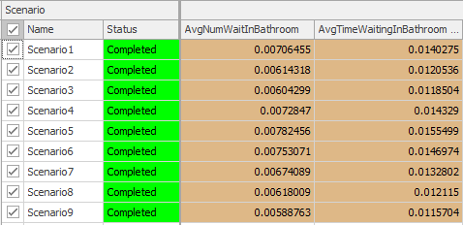

1. **Average Number Of Fast pass and Regular pass customers in the park**

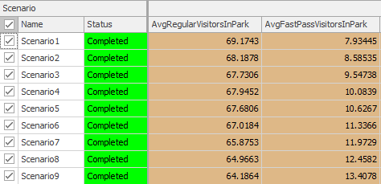

1. **Average and Max Wait Time**
2. **For Regular pass and Fast pass customers for Roller coaster ride.**

Regular Pass avg and max wait times are defined as:

**RegularPassRCMaxWaitTime** and **RegularPassRCAvgWaitTime**

Fast Pass avg and max wait times are defined as:

**FastPassRCMaxWaitTime** and **FastPassRCAvgWaitTime**

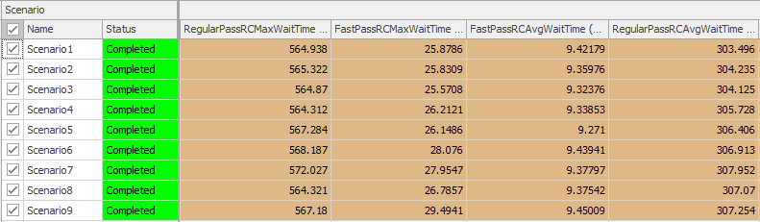

1. **For Regular pass and Fast pass customers for Ferris Wheel ride.**

Regular Pass avg and max wait times are defined as:

**RegularPassFWMaxWaitTime** and **RegularPassFWAvgWaitTime**

Fast Pass avg and max wait times are defined as:

**FastPassFWMaxWaitTime** and **FastPassFWAvgWaitTime**

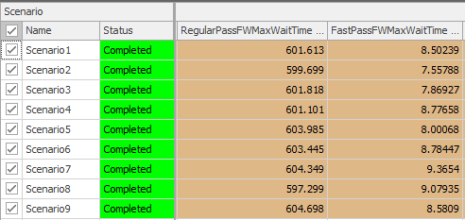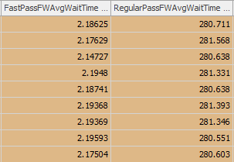

**4. Average ride wait times for Fast pass and Regular pass customers in the park**

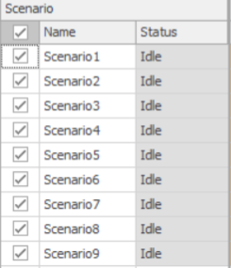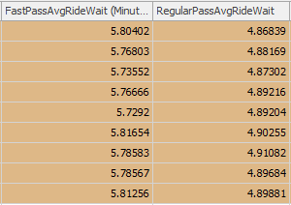

**5. The fast pass percentage is defined from 12% to 20% for 9 scenarios, which will provide max satisfaction for fast pass and regular pass customers.**

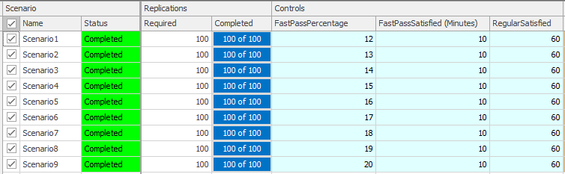

**Appendix:**

This section lists the details of the project rubric described in slide 15 of the project description. To start with, Fast-Pass vs. Regular Customer Distinction and Fast-Pass prioritization fast prioritization was accomplished by differentiating both fast pass and regular customers and setting priority as soon as a customer entered the park as explained in the initial report above. Also, prioritization lines are set in the model identifying the fast pass and regular customer allowing prioritizing the fast pass line for all the activities based on other specifications.

Waiting line avoidance above the given limits, wait line balking is accomplished setting the maximum capacity and balking conditions to a 100 for Roller coaster and 80 for Ferris Wheel ride. In that case, if the number exceeds the maximum allowed customer wait number, the customer will return to the central node and choose another activity.



Recording and collecting fast-pass and regular customer wait times individually was performed in a similar fashion as waiting line avoidance. The below screenshot shows both Fast pass and regular customer noted individually. This allows to calculate the wait time for both the customers individually. For instance, when a customer exits the park, the details are collected in order to calculate the total wait times for both fast pass and regular customers individually and as a group. The below screenshot shows the designated fast pass and regular customer line for Ferris Wheel.

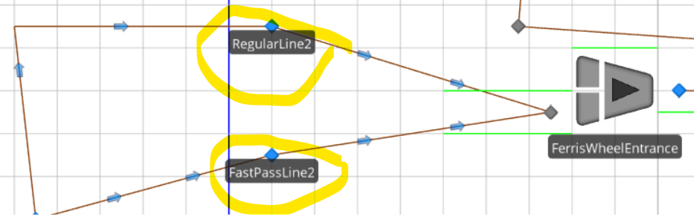

Modeling fast-pass customer percentage in the model, experimentation utilizing various levels. This was accomplished by creating a real property and setting the default value to 15 as listed in the problem description and can be seen in the experiment tab screenshot below. This will help analyze how the change in fast-pass customer percentage will affect wait times and overall utilization for different activities.

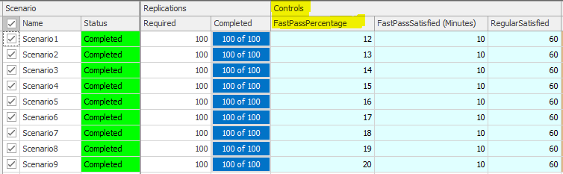

Assigning satisfaction category for each customer type depending on roller-coaster and Ferris-wheel wait times, computing satisfied customer percentage. To accomplish this, individual satisfaction for both fast pass and regular **alking**customers along with overall customer satisfaction was added as response variables. Not to mention, the number of regular and fast pass users along with the wait times for all the activities is also noted by adding response variables as shown in the results tab in the experiment.



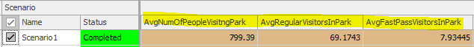



Modeling and validating Time in Park, visit limitations to specific destinations (bathrooms, concessions etc.) To accomplish this, a detailed logic has been included for each parameter which is included in the report above. For instance, the state variable BathroomMax has a logic allowing a customer to use the bathroom area for a maximum of two times. In addition, time in park is noted by assigning logic setting the probability and time as per the model description explained in details above in the report. Consequently, this allows the model to limit the number of times customers can visit an area which is set using a logic in the central node which helps calculate whether the customer is done with his maximum allowed visit to a specific area. Given that the maximum visit is done by a customer, he should select another activity or area to visit while in the park.

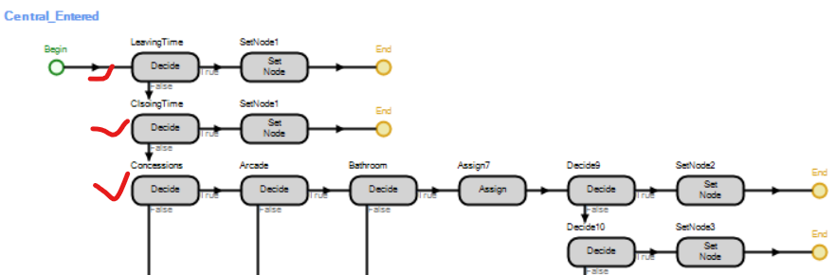

General model specifics are accomplished by noting and applying logics to complete that in the Simio model. To start with, as soon as the customer enters the park they are designated as either fast-pass or regular customer which is done by creating an add-on process at the customer node. Following this, the customers are designated as fast pass or regular based on the lines as noted in the simulation file which will allow a customer to follow the line he has the ticket for – either a fast pass ticket or a regular ticket. This logic runs throughout the model and is further utilized to calculate the wait times for both the customers individually and overall wait times. In addition, how satisfied both the customers are along with the overall customer satisfaction is also noted. To further restrict the visit per customer for a specific area or activity, a central add-on process is created which helps assign the number of times a customer has visited each area and directs a customer to visit another area in case of maximum visits reached. For instance, bathroom visits are limited to two and the other condition saying 50% customers do not wish to visit the arcade is considered in both at the node and logic for central node.

To conclude, the model ran without any errors and was helpful in computing all the desired wait times, activities for both the customers, the number of visitors in the park, the overall customer satisfaction and other information as required in the description. Overall, the report considers all the information as specified in the project rubric and accounts for each of the listed model requirements.